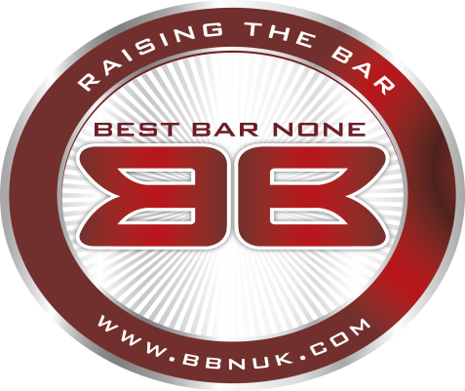

Luton Scheme 2018

Overview

And

Application Form

Coordinator : Steve Evans FBII.tp
M: 07413961953
E: steve@protocoltrainingac.org.uk

Overview

The Best Bar None Scheme is an inclusive national awards scheme for all licensed premises across England, Wales, Scotland and Northern Ireland. It is designed to reward good practice and lead to an enhanced customer experience.

Best Bar None maintains and raises standards and rewards good management of those venues that attain the Award. This is delivered at a local level by active partnerships between the industry, local authorities, the Police and the private sector.

The Assessment is based on core national standards with local flexibility to ensure it addresses local needs.

Assessment of licensed premises will be carried out by competent, impartial, qualified assessors, who will ensure consistency of approach. The assessment criteria will be clear and straight forward, with a minimum of bureaucracy and with constructive feedback provided to all entrants.

Five Easy Steps

- You should complete a short application form.

- A trained assessor will contact you to arrange a mutually convenient appointment to visit your premises. Trained assessors carry out the assessment which lasts between 1 and 2 hours. Assessments are based on the essential, desired and bonus criteria in the scoring documentation.

- Your assessment will be scored and, subject to reaching all the criteria essential to your premises, you will receive a Best Bar None accreditation.

- Some Best Bar None schemes may award a top prize for the highest scoring premises. If you rank within the top scoring premises your assessment paperwork will be put before a judging panel, who will decide the winner and runner-up for each category. Feedback for all premises will be available from the assessors.

- If you pass your assessment and receive Best Bar None status, your premises details will be added to the Best Bar None scheme website with links available to your own, and other relevant websites. Additionally, you will be able to display the Best Bar None logo on your website and all advertising literature.

Premises which pass the Best Bar None accreditation will also receive publicity within local and trade press and other publications.

Your Personal and Business information is held securely, in full compliance with GDPR for the purpose of this award scheme and will not be disclosed to any third parties.

BBN Application Form

Designated Premises Supervisor:…………………………………………………

Premises Name:…………………………………………………...........................

Premises Address:…………………………………………………………………..

…………………………………………………………………………………………

…………………………………………………………………………………………

…………………………………………………………………………………………

Postcode:…………………………………………………………………………….

Telephone Number:……………………………………………….........................

Email Address:………………………………………………………………………

Premises Licence Holder’s Name (if different from DPS):

…………………………………………………………………………………………

Area Manager’s Name: (if applicable)……………………………………………..

Address:…………………………………………………………….........................

…………………………………………………………………………………………

…………………………………………………………………………………………

Telephone Number:……………………………………………….........................

Email Address:………………………………………………………………………

